BRCGS Directory Quick start guide for Companies
- About the BRCGS Directory
The BRCGS Directory is the official database for all BRCGS audit records and affiliate programs. It hosts audit reports, certificates and associated data (including withdrawal & extension information) for all BRCGS audited sites.
Only BRCGS approved Certification Bodies can add or edit information. All audit records are allocated to an ‘owner’ company, who may then choose to ‘share’ their audit record with other companies on the Directory.
Audit sharing gives recipient companies access to all audit data for a particular site and Standard, until such a time that the audit owner elects to remove access.
The Directory includes a reporting suite for the export of consolidated audit data, and notifies users of certification events related to audits they own or are shared with them.
- Terminology Guide

- Certification Body (CB) – BRCGS approved organization that conducts audits and adds resulting data to the Directory
- Site – location subject to the audit & referenced in the audit report. All site records are linked to an ‘owning’ company
- Site code – unique & permanent reference number allocated to each site by the Directory, located on audit reports & certificates
- Company – organization that owns one or many sites or the audits associated to a site, or has audit records share with them
- Audit record – hosts all audit & certification data for a particular site and Standard, including access to previous audits of the same Standard. Audit records include access to PDFs, upcoming audit dates and reasons for expiry/revocation. All audit records are allocated to an owning company, typically the company that owns the site referenced in the audit record
- Audit ID - unique & permanent reference number allocated to each audit record to aid location
- Company ID – unique & permanent reference number allocated to each precise location
- Audit sharing – in audit-record tool that allows audit owners to give other companies and CBs access to their audit records
- Current/closed – A site’s most recent audit record for each Standard is allocated Current record status, irrespective of its age. When an audit record is superseded with a renewal audit, the previous record is allocated ‘closed’ status
- Site sharing – CBs can only upload audit records or edit site records which are shared with them. A company that owns a site (or BRCGS) should share their site with a new CB prior to audit upload
- Public Directory – openly accessible, searchable, list of currently BRCGS certificated sites and approved Certification Bodies

- Directory quick navigation
Audits – all audit records are located in the Audits area
Companies – all site and company records
Reports – basic reporting suite allowing users to export pre-defined reports in .CSV and .XLS
Notifications – allows users to choose which events and categories they receive notifications about
- Responsibilities (who to contact)
BRCGS do not make any edits to site, company or audit records.
Approved Certification Bodies are responsible for the following Directory actions;
- Site creation (including site code generation)
- Site record edits/updates
- Company creation, updates and company contact maintenance
- Site to owning company configuration
- Audit record to owning company configuration
- Adding audit reports to the Directory
- Updating audit record content, including corrections and changes to certification status
- Adding or removing a site from display on the public Directory
CBs can edit any audit record they have created - and can create audit records for any site they have either created or has been subsequently shared with them.
CBs can also edit any company or site detail (including updating contacts) for any site/company they have either created or has been subsequently shared with them.
Companies and sites can be shared with a CB by BRCGS or a Directory user account holder from the company itself.
User account creation
A user account is created for every company when the company is first set-up on the Directory by a CB.
Additional user accounts can be created by; BRCGS on request, CBs on request, other account holders at the same company

- How to…

  - Request a new Directory user account
Complete the following form https://form.jotform.com/61322554434955
  - Password reset for an existing user account
Use the ‘Forgot password’ option from https://directory.brcgs.com/
  - Apply for a BRCGS logo
Complete the following form https://form.jotform.com/61323530244949
  - Locating audit records
To locate an audit record, login to the Directory and open the Audits area. All available audits are listed.
Users can search for a specific site by site name or by audit ID – or by applying filters available at the header of each column
  - Locating audit reports, certificates and other PDF documents
After locating the required audit record in question, click on the orange Audit ID number to open the record.
Audit reports and Certificates can be downloaded from the Menu tool in the top right corner.
Choose ‘Download Certificate’ to obtain the Certificate or ‘Download as PDF’ to download the report itself.
If Download Certificate is not a visible option, it means the issuing CB has yet to add the document to the Directory.
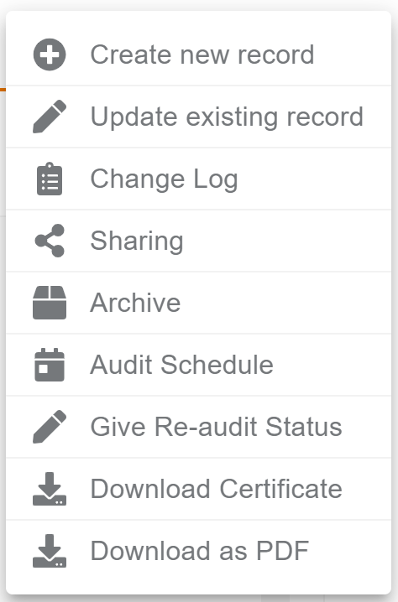
  - Audit sharing
To share an audit record with another company or a CB – locate the audit record in question in the audit list & select sharing from the quick-menu in the left hand column. This will open the sharing selection page.
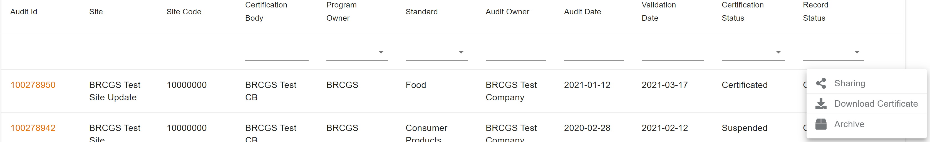
Enter the company name or unique ID to locate the company you wish to share the audit record with. Once located, select Share from the right-hand column. Account holders associated to the company in question will now be able to access the audit record until that box is un-checked.
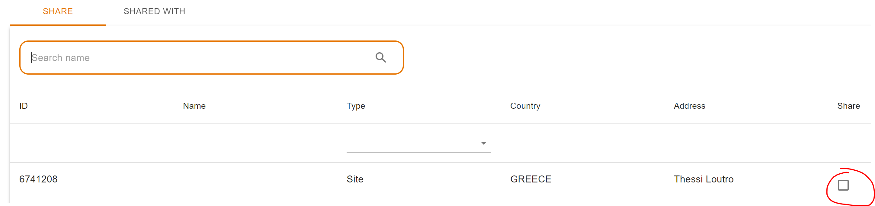
  - Site/company records with CBs
To share a site or company record with a CB – open the Companies area, followed by the Sites tab. All sites associated to your company will be listed.
The search tool will allow location of a specific site record and will accept either site code or site name.
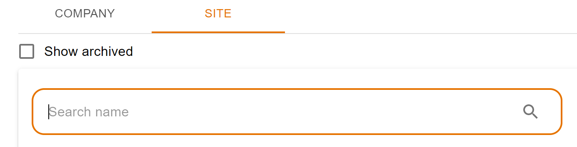
After locating the required site record, open the record via the orange Site Code text, open the Menu tool in the top right corner and choose ‘Sharing’ This will open the sharing selection page.
Enter the name CB you wish to site record with. Once located, select Share from the right-hand column.
Account holders associated to the CB in question will now be able to edit the site record and create further audits for that site.

